**Tutorial 17: Slots**

Slots are useful for passing custom templates into components. You do not use slots to pass data. We can create customisable slots that has a specific name that serves a specific purpose.

Make sure **Tutorial 16** is complete to be able to move on to this tutorial or clone the [vue3-firebase-course](https://github.com/younggrasshopperza/vue3-firebase-course) repository and go to branch called **Tutorial-16**.

**Step 1:** In the Modal.vue file, remove the h1 and p tags in the template. Remove the header and text props. Inside the div tag with a class of modal add the slot tag.

Look at the example below (**Line 5**):

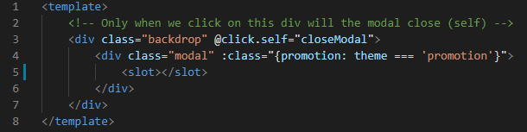

In the App.vue file, remove the header and text props that are inside the Modal component. Create a closing tag for the Modal component. Inside the Modal component add an h1 and p tag with some text.

Look at the example below (**Between** **line 5 and 8**):

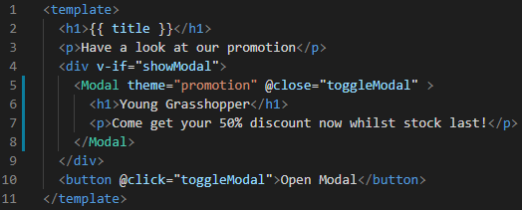

**Output:**

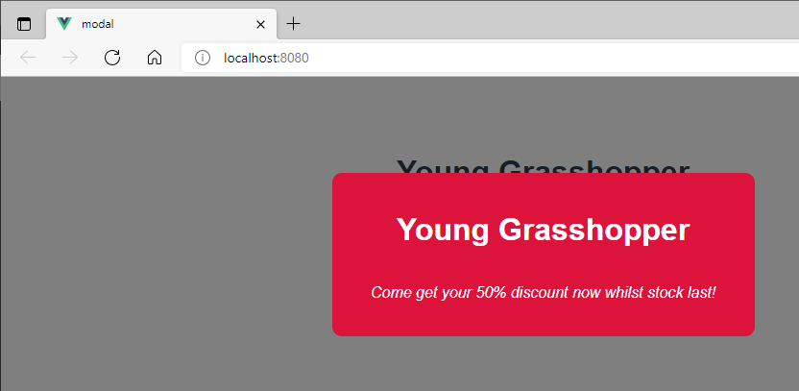

**Step 2:** In the App.vue file, create a template inside the Modal component and give the template a slot name called links.

Look at the example below (**Between** **line 6 and 9**):

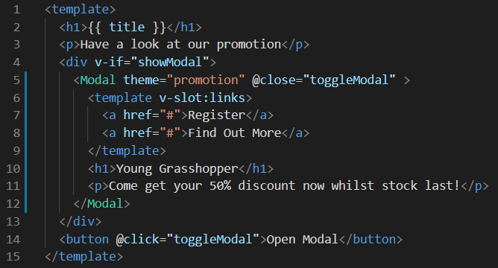

In the Modal.vue file, add div with a class called actions. Inside the div add the slot with the name links.

Look at the example below (**Between** **line 6 and 8**):

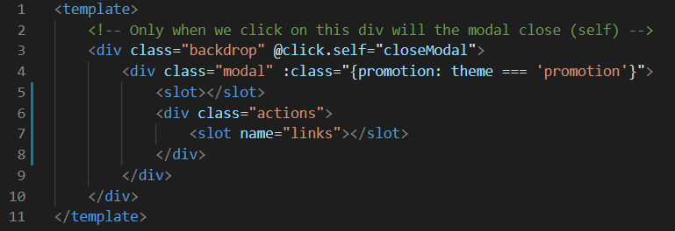

Add some CSS code in the Modal.vue

.modal .actions {

    text-align: center;

    margin: 30px 0 10px 0;

}

.modal .actions a {

    color:#333;

    padding: 8px;

    border: 1px solid #eee;

    border-radius: 4px;

    text-decoration: none;

    margin: 10px;

}

.modal.promotion {

    background: crimson;

    color: white;

}

.modal.promotion h1 {

    color: white;

}

.modal.promotion .actions {

    color: white;

}

.modal.promotion .actions a {

    color: white;

}

**Output:**

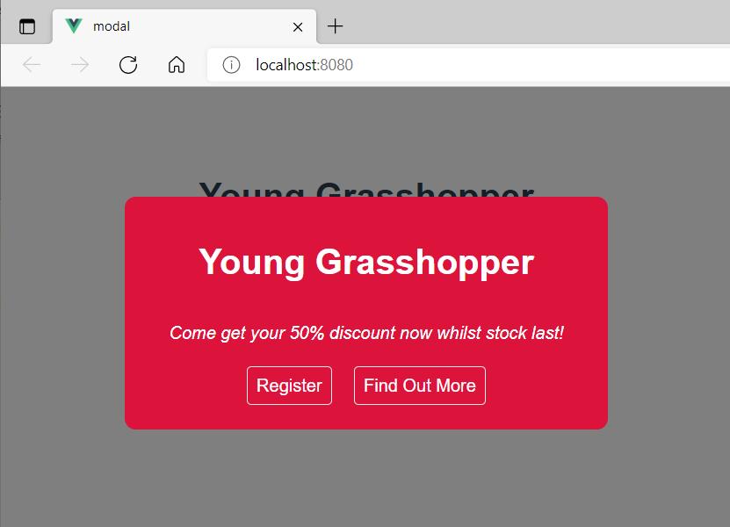

**You can view the code snippets from the** [**vue3-firebase-course**](https://github.com/younggrasshopperza/vue3-firebase-course) **repository under the Tutorial-17 branch**.